R. Reports Menu: 6. Comment Report

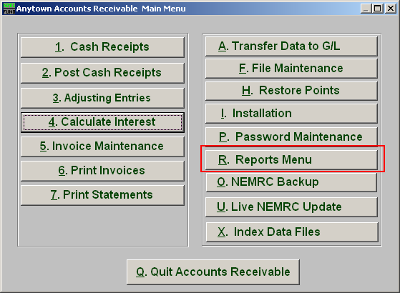
Click on “R. Reports Menu” from the Main Menu and the following window will appear:

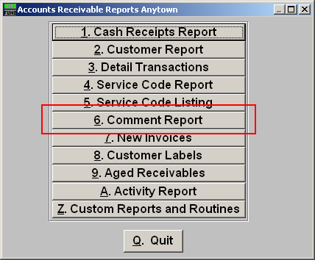
Click on “6. Comment Report” from the Reports Menu and the following window will appear:
Comment Report

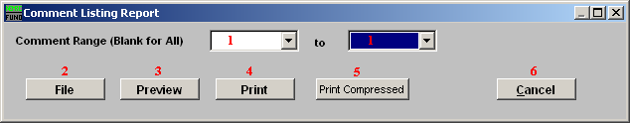

- Comment Range: Enter a service code range or click on the drop down arrow and select from there. Leave Blank for All.

- File: Click this button to save on this computer. Refer to GENERAL FILE for more information.

- Preview: Click this button to preview. Refer to GENERAL PREVIEW for more information.

- Print: Click this button to print. Refer to GENERAL PRINTING for more information.

- Print Compressed: Click this button to print the report. This is different from the “Print” option in that it will use less paper for the same report.

- Cancel: Click “Cancel” to cancel and return to the previous screen.

